**HTM atomic shared pointer**

**1. 구현 설명**

- call by value에서 call by reference 로 수정



- load()에서 불필요한 htm transaction 제거

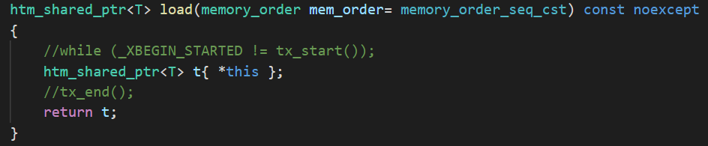

- abort 원인 count

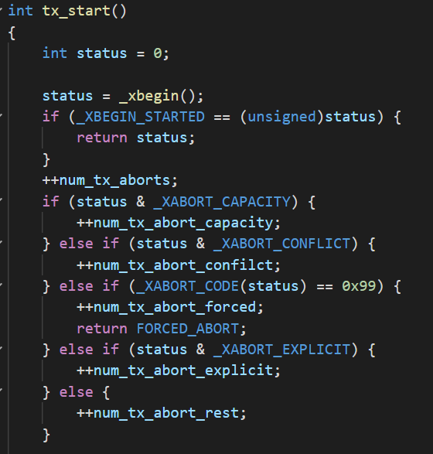

**2. 성능 측정**

**- 40000번 테스트 소요 시간 (ms)**

|  |  |  |  |  |  |  |
| --- | --- | --- | --- | --- | --- | --- |
|  | 일반 | Atomic load/store | Mutex_share_ptr | Htm_shared_ptr | Htm_shared_ptr + fallback | **Fully_htm_shared_ptr** |
| 1 thread | 22 | 411 | 676 | 673 | 654 | **2896** |
| 2 thread | 19 | 504 | 3020 | 1327 | 342 | **3381** |
| 4 thread | 16 | 402 | 1413 | 675 | 185 | **1333** |
| 8 thread | 15 | 366 | 5153 | 6313 | 147 | **1796** |
| 16 thread | 15 | 370 | 4196 | 4631 | 152 | **1905** |

- abort 횟수 (HTM_set)

|  |  |  |  |  |  |
| --- | --- | --- | --- | --- | --- |
|  | 1 thread | 2 thread | 4 thread | 8 thread | 16 thread |
| total aborts | 1036 | 45326237 | 25373361 | 83054145 | 104213281 |
| capacity aborts | 7 | 222 | 945 | 15060 | 11890 |
| conflict aborts | 147 | 45320017 | 25366618 | 83025454 | 104189774 |
| forced aborts | 0 | 0 | 0 | 0 | 0 |
| explicit aborts | 0 | 0 | 0 | 0 | 0 |
| rest aborts | 882 | 5998 | 5798 | 13631 | 11617 |
| total commits | 68854438 | 68006863 | 67113777 | 68555605 | 68603744 |